1. 
2. **App folder**: This folder contains all our angular code.   
   All the components and modules would be in here.
3. **Assents** **Folder**: Containing all the images.
4. **Environments Folder:** When we develop app, we deploy in multiple environments. Local, Development, QA, Test, Production.   
   Configuration for each type of environment, goes into this folder.
5. **Tsconfig.json file**:  
   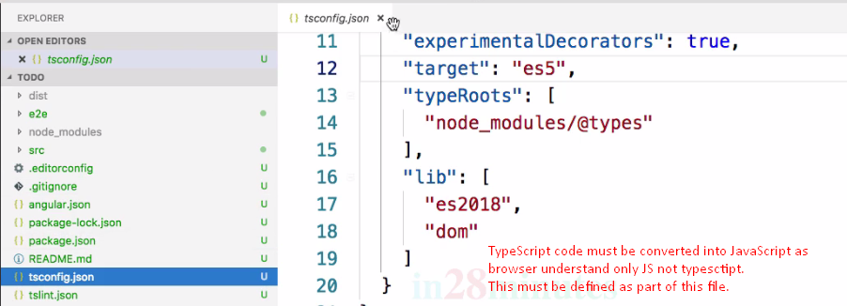
6. 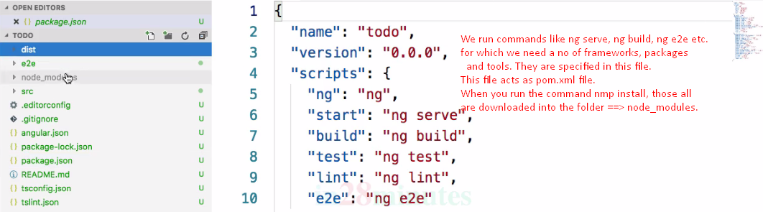  
   **NOTE**: When we run ng new, npm install command is executed automatically.
7. **.gitignore file:** Specifying the files which should not be committed to version control.
8. **Main.ts and index.html:** These two files are responsible to bootstrap our angular app.
9. **Polyfills.ts**: To fill the gaps for the js codes b/w the different browser. Actually, to make js code compatible.
10. **Styles.css:** Having global app styles.
11. **test.ts:** this file is the starting point for running the unit tests during the command 🡺 **ng test**
12. **tsconfig.json:** How to convert typescript code into js.